Ean Masoner Module 6.2 Assignment

Screenshot after running code in terminal

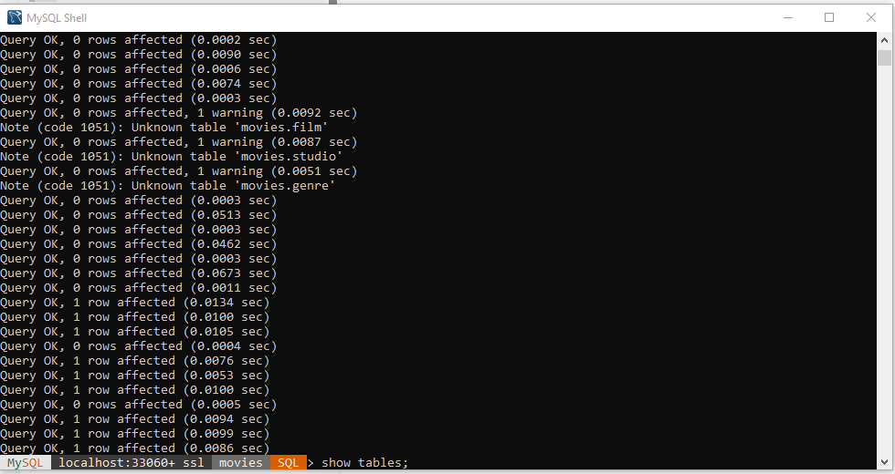

ScreenShot after running show tables command

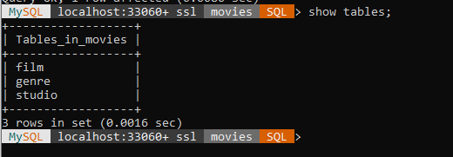

ScreenShot after running code in terminal

